**Abstract**

This report serves as the second deliverable for the Platforms for Computing module, Assignment 3. Contained within are three parts to it: hardware and software troubleshooting as per the given scenario, with a review of the methodologies and techniques used; network troubleshooting as per the packet tracer simulation provided, with a review on the methodologies and commands used to diagnose connectivity issues; a portfolio containing five previously completed exercises to the course units, with an evaluative conclusion.

4WCM0019-0105-2020 - PLATFORMS FOR COMPUTING (COM)

Reece Alqotaibi | 19063069

Assignment 3: Technical Report

2021

Table of Contents

Hardware and Software Troubleshooting 3

Preface 3

Task One 3

Brief 3

Troubleshooting 3

Task Two 5

Brief 5

Troubleshooting 5

Task Three 6

Brief 6

Troubleshooting 6

Network Troubleshooting 11

Exercise Portfolio 13

Unit 1 – Exercise 1 13

Requirement 13

Unit 7 – Exercise 1 15

Requirement 15

Intranet 15

Extranet 15

LAN – Exercise 1 16

Requirement 16

Fully Connected 16

Mesh 17

Bus 17

Star 18

Ring 19

LAN – Exercise 2 20

Bridge 20

Firewall 20

Hub 20

Laptop 20

Modem 20

Network Interface Card 20

Printer 20

Repeater 20

Router 20

Server 20

Switch 20

Workstation 20

Wireless Access Point 20

Gateway 20

Multilayer Switch 20

Proxy Server 20

VPN 20

Layer 12 – Exercise 1 20

A History of Personal Computers 20

Conclusion 21

# Hardware and Software Troubleshooting

## Preface

I have chosen to write documentation predominantly for Windows Operating Systems, as it is a widely regarded fact that average users work on Windows based operating systems.

Steps taken on Windows are like steps taken on other operating systems such as Linux and OSX, but menus and terminology may be different.

## Task One

### Brief

*The printer is turned on, and when the user tries to print from MS Word, for example, they can see a printer, but no printing can be done.*

### Troubleshooting

Printers are the bane of most IT peoples lives, as there is so much variety in how drivers handle print jobs and spooling. There are a specific set of steps that should be followed when troubleshooting printers, and each of the steps can prove to be more difficult than expected. The general order, which I have built up over my years of experience in IT and rarely fail me.

**Check the printer is online**

Just because a printer is powered on and is visible as a printer to use, does not mean it is online. Windows is a good example of this as Windows remembers all added printers and shows them as options in the printer list regardless of whether they are online at the time of printing.

**Check Cable Conditions**

If the printer is networked, check the Cat5 cable that is connected to the printer. Checking should involve inspecting the condition of both terminals (check if each cable inside the PVC is connected to a pin in the terminal, and that the terminal is not loose). Checks for crimps, cuts, or kinks in the cable are done too. If visual inspections are normal, then using a Cat5 cable tester is the next step.

If the printer is a local USB or Parallels cabled printer, inspect the terminals and pins where appropriate, and then check for kinks or crimps in the cable.

Replace where necessary.

**Clear Printing Queue**

Open the Control Panel and navigate to Printers. Optionally, ‘control printers’ can be entered into a Run command box, or from the command line itself.

Right click the printer in question and click on ‘See what’s printing’.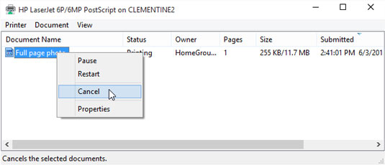

Date Unknown | Andy Rathbone | How to Cancel a Print Job in Windows 10 | <https://www.dummies.com/computers/operating-systems/windows-10/how-to-cancel-a-print-job-in-windows-10>

**Restart the Print Spooler Service**

Open the Task Manager and click the ‘Services’ tab. Scroll down to ‘Spooler’, right click it and click on ‘Restart’.

**Update Driver for Printer**

The method for updating a printers driver varies greatly by manufacturer. Refer to the operating manual or check the manufacturers website for specific instructions on how to do this.

**Uninstall and Re-Add the Printer**

Open the Control Panel and navigate to Printers. Optionally, ‘control printers’ can be entered into a Run command box, or from the command line itself.

Right click on the printer in question and then click on ‘Remove’.

Adding the printer varies by manufacturer. Refer to manufacturers instructions for required software.

If the problem is still not resolved then further investigation is required, or often vendor support is needed. Go through appropriate channels to obtain help from the vendor.

When resolved, create documentation however is standardized at the place of work, either through documents or dedicated knowledge base software. Be sure to include all steps taken to resolve the problem, including any extra anomalies found and supplemental information such as known bugs, etc.

## Task Two

### Brief

*The USB devices seem to not be recognised*

### Troubleshooting

**Isolation**

The first step to troubleshooting USB issues is to isolate the problem directly between the USB device and the computer it is connected too. This means ensure that the device is not connected to a USB hub or adapter.

**Disconnect and Restart**

In my experience, most problems have been resolved by simply disconnecting and reconnecting the USB device. If this fails, it is usually followed by a restart which normally solves the problem.

**Update USB Device Driver**

Device Manager will list all connected USB devices, recognized or unrecognized. Using Device Manager, you can update the driver software, either through Windows Update or manually. Windows Update does a ‘best match’ update and is usually the first approach taken.

Open Device Manager from the Start Menu and expand the Universal Serial Bus Controllers tree view.   
At this point if the device is not listed, it is because Windows physically cannot see the device as being connected. This normally is where a cable replacement would be done if possible – if not then the hardware is likely defective.

If the device is listed, right click it, and select ‘Update driver.’

Follow the wizard as instructed.

**Windows USB Troubleshooter**

Microsoft have a free tool available called the Microsoft Windows USB troubleshooter and is available to download from the Microsoft website. Download and run this tool, following all recommendations as advised.

## Task Three

### Brief

*The computer is very slow, applications hang forever, but otherwise, the mouse and keyboard are working.*

### Troubleshooting

#### Understanding Scope

Root cause analysis for slow systems is a very tedious process and requires a broad skillset and use of industry standard diagnosis software.

The first step to identify slow computers is to perform some basic information collection.

* CPU Age, Cores, Threads, Clock Speed and Condition
* Memory Speed, Size, Age and Condition
* Hard Drive Type, Age, Size and Condition
* Base Requirements
* Application specific requirements

After obtaining the above information we can begin to identify whether the operating system and running applications are supported on the hardware you are using.  
  
For example, Windows alone requires the following specification to run:

Date Unknown |Microsoft Corporation | Windows 10 System Requirements | <https://support.microsoft.com/en-us/windows/windows-10-system-requirements-6d4e9a79-66bf-7950-467c-795cf0386715>

If your system matches the above information, we now need to determine whether the applications running can run on Windows. A common mistake people do is to forget that every application running has requirements that are in *addition* to the base Windows install.

For example, Visual Studio 2019 has the following requirements:

April 2nd, 2019 | Microsoft Corporation | Visual Studio 2019 Product Family System Requirements | <https://docs.microsoft.com/en-us/visualstudio/releases/2019/system-requirements>

Assume for a second that the machine in question has a 64-bit, 2.4Ghz dual core CPU, 64GB Solid State Drive (SSD), and 8GB Memory.

If we want to run Visual Studio efficiently on this machine, we must combine the two requirements and compare them against the machine with problems.

|  |  |  |  |  |
| --- | --- | --- | --- | --- |
| Subsystem | OS Requirement | VS 2019 Requirement | Our Specification | Requirement |
| CPU | 1Ghz Dual Core | 1.8Ghz Quad Core | X.XGhz Quad Core | X.XGhz Dual Core |
| Memory | 2GB | 2GB (8GB Recommended) | 8GB | 4GB (10GB Recommended) |
| Hard Drive Size | 20GB | 20GB (50GB Recommended) | 64GB | 40GB (74GB Recommended) |
| Hard Drive Type | Unknown | SSD | SSD | SSD |

As seen in the table above, individually we meet all the requirements for both the OS and VS2019. However, remembering that we need to combine the two we can see that we fall short in three of four requirements.

**Note**: 74GB requirements are only needed when all VS 2019 components are installed and is practically not going to get to this limit, but instead used as a demonstration.  
  
**Note:** CPU GHz requirements are hard to gauge, as the CPU does not need every MHz of a CPU all the time.

We can conclude that from our information collating that our machine simply does not meet the recommended specification.   
  
As a result, we should expect performance instability, especially if we have other applications running in the foreground and background (services).

#### Diagnostic Tools

If our machine meets the requirements, then we need to figure out what is causing the performance issues. The first step we can do identify this is by using the Task Manager.  
  
The above image of Task Manager shows how much CPU and memory are being used at any point in time on the machine. This can be used to show which applications are ‘hogging’ system resources. Closing applications that are doing this may render the system usable again.

If not, we must continue our troubleshooting by using further tools. A brief explanation of the main tools I have used extensively in my experience as both a first line tech support and Systems Administrator roles is listed below. The first three tools are part of the Microsoft SysInternals Suite.

**ProcMon**

ProcMon, short for process monitor is used as a live view for every single call a process makes in Windows. Malware and viruses are often a big culprit for slow operating systems. One of the many uses of ProcMon is to identify any suspect process calls being made.

Investigating these calls is a tiresome job, but many times I have found a user has malware on their machine and a rogue process is ‘spamming’ calls out to the CPU which is rendering it unusable.

**Sysmon**

Sysmon is simply a system monitor that logs all recorded activity and outputs this verbosely to the event viewer, providing easy to read diagnostic information.

**RamMap**

RamMap is used to identify what is currently being used in memory, and through investigation and knowledge can show stale blocks of ram. Often applications have been built without any garbage collection implemented. This can lead to memory leaks which keeps consuming ram without clearing the ram it has previously used and is no longer using.

This tool offers options to clear out every ram address in the system, so extreme caution should be used when using this tool.

**CrystalDiskInfo**

CrystalDiskInfo is an incredibly useful tool that lists the status of drives on the system. It shows real time information about corrupt/missing/unallocated sectors on the drive, which goes in part to show the overall health of a drive.

Using a combination of all the tools above has often led me to the answers I have been looking for when diagnosing system performance issues. Often it is the case that the system does not have enough resources, or that a particular application has memory leaks.

System resets and operating systems are a viable option for resolving issues, but this should generally be a worst-case scenario, and backups should be made to ensure minimal data loss.

# Network Troubleshooting

As soon as Packet Tracer was opened, and I had the IP addressing scheme available I decided to approach this just as I would any real-world scenario. So that I could begin detecting what problems were present, what the symptoms were, and how many machines were affected I started by identifying any visual problems and making notes of these as I went along.

As per the specification, the LAN address should be set to 192.168.0/24 and the gateway should be 192.168.0.1, so the first thing I did was to manually attempt to send packets to the gateway to determine if the gateway itself was reachable.

For each device tested I got the same output:

After doing this I had a 100% failure rate on each client tested. This indicated that there was a wider problem that needed addressing.

As nothing could ping the gateway, but everything was showing as connected, I decided to check the settings for the LAN interface on the wireless router. Surely enough the configured IPv4 Address for the wireless router was set at 192.168.2.1. This does not match the 192.168.0.1 specified in the IP addressing scheme. I changed this as required and then tried to ping the gateway from each client again.

For both laptops, and PC1 I got the following output:

This indicated to me that there was a problem exclusive to PC2 that needed to be resolved, as I was still getting the same output from the ping command as I was before.

Running the command IPCONFIG in the command line on PC2 resulted in the following:

Bluetooth is not an issue here, but I quickly noticed that the configured IP address and default gateway for PC2 were not as they should be, according to the IP addressing scheme.

I went into the IP addressing config for this machine and set the default gateway to 192.168.0.1 and assigned it a static IP address as 192.168.0.202. Then I ran another ping test, which resulted in:

Success! Now each client on the network was able to send and receive packets to and from the gateway as required in the brief.

# Exercise Portfolio

## Unit 1 – Exercise 1

### Requirement

*As an individual, you are tasked with researching and explaining in the form of a brief (approx. 800 word) report (and in your own words) what the Universal Serial Bus is, how it technically works, how it has evolved, what its advantages & limitations are and how it supports ‘Plug & Play’ technology.   Conclude your research with a personal, critical reflection on how the USB platform impacts compatibility and connectivity as well as explaining how its impacts user experience and expectation (include examples*

**USB – The Standard that Revolutionised Connectivity.**

The USB, short for Universal Serial Bus is perhaps one of the greatest achievements we have made in terms of peripheral connectivity. Looking back since its inception it has changed the way devices of all size and shape, form and function connect and integrate with modern day hosts.

From a technological standpoint the USB is simply a series of shielded wires inside a cable housing. Inside the housing consists of four coloured wires. There is a red wire to deliver up to 5 volts and a brown wire to provide grounding – these are untwisted. There is also a twisted pair of wires, blue and yellow in colour that enable the data link between the device and the host.

When a device is attached via USB it uses the plug and play specification which allows the host to automatically detect the device type and load a driver for it and begin transmitting data. From I high level perspective data is sent between the peripheral and host system in a very similar way to how data is sent across network devices – a packet. Some of the information in this packet includes the source and destination, as well as the length of the data that is being transferred.

**A Brief History**

The USB has evolved significantly over time, not only to meet the demand of faster data transfers, but also for ease of use to the consumer. When the first widely used version of the USB was released in 1998 (USB 1.1) it boasted two different sets of transfer rates: 1.5Mbit/s (Low Speed) and 12Mbit/s (Full Speed), utilised by the type of USB device. Devices such as keyboards and mice did not demand large transfer speeds and so used the Low-speed rate. Other devices such as printers and external floppy disk drives required full speed.

April 2000 saw the release of the USB 2.0 specification and perhaps was the driving force for major companies such as HP, NEC, Philips, and Intel to invest heavy research and development into increasing the transfer speeds that USB is capable of. Overwhelming success was the result, as USB 2.0 was released to consumers with a data transfer speed of 480Mbit/s.

There were no further changes to the USB 2.x specification for many years, and 2008 saw the release of USB 3.0 which had data transfer capability of up to 5 Gbit/s along with the ability to provide more power to devices, with decreased power consumption. Changes in the standard di not necessarily mean a change in the ports used to connect. USB 3.x was designed to be backwards compatible with older USB 2.0 devices (but running at 480Mbit/s). This was possible due to using two buses in parallel: one for USB 2.0, and one for USB 3.0 – dubbed SuperSpeed.

There have been a further two revisions to the USB 3.x specification. USB 3.1 was released in July 2013 with speeds of up to 10Gbit/s and maintained backwards compatibility with USB 2.0 and USB 3.1, although it was able to use SuperSpeed+, a revision to the original SuperSpeed. 2017 saw USB 3.2, the current generation released with data speeds of 20Gbit/s.

There have been multiple form factors for types of connectors used for USB devices. In total there have been three major form factors, A, B and C, with a variety of each introduced in between.

**The Good, the Bad and the Ugly**

The USB specification has provided devices significant advantages over its predecessors. For example, before the USB the standard way of transferring data was through floppy diskettes and Compact Disks (CD), both of which had their own problems. Floppy disks were highly susceptible to data loss through magnetic interference. CDs on the other hand were not susceptible this way but faced their own challenge in that data loss and corruption was a likely result of surface scratches. USB Flash drives instead use flash media to store and retrieve the same types of information that were held on its predecessors and are not susceptible to data loss through either magnetic interference, or surface scratches.

It is not all good news for the USB as there are several disadvantages that come with it. Generally, USB peripherals have short cables, usually up to a few feet, making connecting devices from across the room, or another building impractical. Further to this, USB devices cannot generally interact with each other and two hosts cannot directly communicate over their own USB ports. Due to the design of modern USB flash drives and their decrease in physical size it stands to reason that there is significantly more chance of losing a drive than there was a floppy diskette or a CD. Losing a flash drive which has much higher storage capacity increases the chance of losing more amounts of data at one.

**A Personal Reflection**

Whilst my overall opinion of the USB is a highly positive one, I believe it to be far from perfect. In addition to some of the disadvantages mentioned there has seen an increase in ‘counterfeit’ devices sold online. These drives are advertised with a large capacity but are usually drives with built in files that have been edited to display the higher value to a consumer.

Another problem people currently face is that they are now accustomed to most USB devices being plug and play, but this is not always the case. Working in an IT capacity has exposed me to the countless times: you plug a device in expecting it to work, unaware that there is a compatibility issue and addition drivers need to be installed. The average user does is not usually aware of the required steps to do this.

I believe the advantages with the USB overwhelmingly outweigh the cons and offer significant enhancements to previous standards, and therefore overall, I believe the USB to be one of the best technological advancements in recent years.

## Unit 7 – Exercise 1

### Requirement

*In small groups (max 3), investigate and research the benefits and potential risks associated with an educational organisation using and running an intranet and extranet service for its stakeholders (i.e., staff, students, external employers, external clients, parents and associated regulatory bodies).*

### Intranet

#### Define

November 16th, 2020 | Charong Chow | What is an Intranet and is it still relevant? | <https://socialchorus.com/blog/what-is-an-intranet-and-is-it-still-relevant-to-your-organization>

An Intranet is a private network that is used by organisations and educational establishments to distribute and share information, as well as to communicate to internal stakeholders across multiple locations and time zones. Many intranets have a Content Management System (CMS) that allows administrators to upload and share information that may be required by the intranets’ users.

#### Benefits

Date Unknown | Hannah Price | 11 undeniable benefits of an intranet | https://blog.jostle.me/blog/benefits-of-an-intranet

* Allows unified access internal resources and communication.
* Offers improved overall efficiency due to dedicated communication medium.
* Connects multiple locations together independent of geographic location.
* Encourages stakeholders to come together and support others with knowledge sharing.

#### Potential Risks

January 18th, 2018 | Becki Hall | The biggest risks threatening your intranet project | <https://www.interactsoftware.com/blog/biggest-risks-threatening-intranet/>

* Poor content management leading to convoluted and hard to find information.
* Requires stakeholders to opt in, which can be troubleshooting and hard to convince them.
* Security mitigation requires technical knowledge to implement and constantly administer.
* Requires effective hierarchical role-based management to be implemented.

### Extranet

#### Define

Date Unknown | Author Unknown | Extranet| <https://www.techopedia.com/definition/2401/extranet>

An Extranet is like an Intranet, but is intended not only for internal stakeholders, but also for external ones such as third-party vendors, customers, and suppliers. Login portals are usually more likely to be found as part of the infrastructure of an extranet to segregate out permissions for the different type of stakeholders logging in.

#### Benefits

Date Unknown | AllBusiness Editors | The Benefits of an Extranet for Your Business| <https://www.allbusiness.com/the-benefits-of-an-extranet-1283-1.html>

* Enhanced collaboration by working with stakeholders to accomplish goals.
* Reduce Cost through documentation and processes such as written support material.
* Information security improvements by allowing all stakeholders to communicate information with each other in a secure environment.
* Improve overall customer service levels.

#### Potential Risks

October 9th, 2018 | IONOS | What is an extranet, and how can I use it? | <https://www.ionos.co.uk/startupguide/productivity/extranet/>

* Implementation can be significantly harder, as there is added complexity to involve all stakeholders.
* Additional training required for all parties to utilise the extranet effectively.
* Additional costs to provide or use (if cloud-based) the required infrastructure.
* Security mitigation is more important than an Intranet, and usually requires dedicated support personnel.

## LAN – Exercise 1

### Requirement

*As an individual research each of the five networking topologies (defined above) and produce a critical review of the strengths and weakness of each; include information such as origin, operational use, complexity, cost, and robustness.*

### Fully Connected

All devices are directly connected to each other.

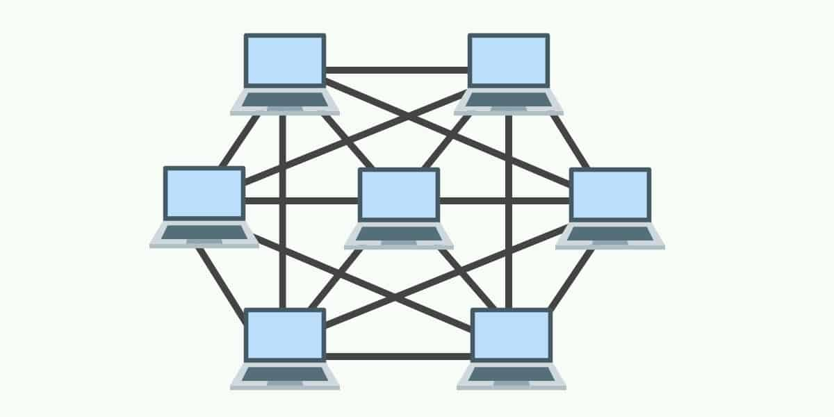

March 2021 | Full Mesh Topology. [Online image] Available from: https://www.comparitech.com/net-admin/network-topologies-advantages-disadvantages [Accessed 28 March 2021]

**Pros**

* Data transfer speed between devices is usually the highest of all topologies, since each machine has a separate physical cable connecting it to the other machines on the network.
* If one cable breaks, the link between the two endpoint machines is broken, but the rest of the network integrity remains intact.
* As a result, fault finding, and diagnostics is usually simpler with this topology.

**Cons**

* Planning and implementation are usually very time consuming.
* Devices can only be connected to a small, finite number of other devices (usually limited by the number of available interfaces to be added to the machine)
* Can be quite messy due to the volume of required cables.

This type of network is usually used in infrastructure backbone, where fault tolerance, robustness and speed are the core values of the network integrity.

### Mesh

March 2021 | Partial Mesh Topology. [Online image] Available from: https://www.comparitech.com/net-admin/network-topologies-advantages-disadvantages [Accessed 28 March 2021]

**Pros**

* Data transfer is still among the highest between nodes, but for certain nodes it can be slower as not all nodes are directly connected.

**Cons**

* Planning and implementation are still time consuming, but less so than full mesh.
* Devices can still only be connected to a small, finite number of other devices (usually limited by the number of available interfaces to be added to the machine)
* Can also be quite messy due to the volume of required cables, but less so than full mesh.

These types of networks are usually used for peripheral networks when connected to strong backbone infrastructure like a full mesh.

### Bus

A single, main cable that connects to all the devices to it. Each device then connects directly to the main cable, usually with a coaxial or RJ-45 splitter.

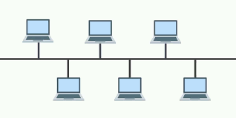

March 2021 | Bus Topology. [Online image] Available from: https://www.comparitech.com/net-admin/network-topologies-advantages-disadvantages [Accessed 28 March 2021]

**Pros**

* Easy to install and configure.
* Extremely low cost
* Scalability is very high.

**Cons**

* If the main cable goes down, then the entire network will drop.
* Unidirectional data transfer
* Speed and performance often unreliable, depending on the number of active nodes.
* Highly susceptible to traffic collision

### Star

All devices connect to a switch, allowing new devices to be added with ease, providing the switch or switches have enough free ports. This is by far the most common topology I have encountered in my professional career.

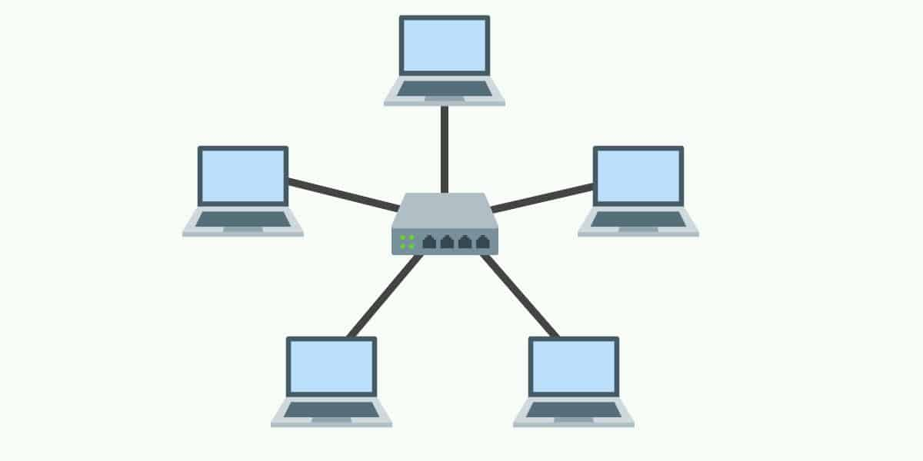

March 2021 | Star Topology. [Online image] Available from: https://www.comparitech.com/net-admin/network-topologies-advantages-disadvantages [Accessed 28 March 2021]

**Pros**

* Centrally managed location
* Easy installation of new nodes and equipment
* Highly durable
* More efficient to diagnose when something goes wrong.

**Cons**

* Usually requires employees to be trained in the use of networking hardware.
* Single point of failure If the switch dies (usually countered with switches working in - failover)
* Can be quite costly to set up reliably.
* LAN speed is 100 percent dependent on the maximum throughput of the switch.

This is the most common type of network used in Local Area Networks.

### Ring

Like an electronic circuit, each node must be always online, and the data must pass through each one to get to the destination.

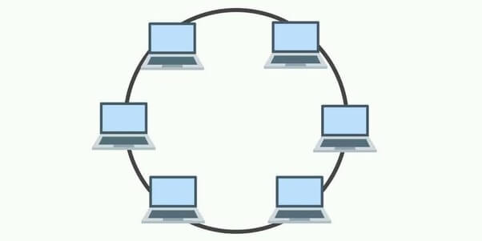

March 2021 | Ring Topology. [Online image] Available from: https://www.comparitech.com/net-admin/network-topologies-advantages-disadvantages [Accessed 28 March 2021]

**Pros**

* Collison unlikely
* Low cost to implement and set up.

**Cons**

* All nodes must be available – the network will drop if a single node fails.
* Adding nodes needs all other nodes to be shut down and reconfigured.
* Speed and performance will drop with each additional node.

## LAN – Exercise 2

### Bridge

### Firewall

### Hub

### Laptop

### Modem

### Network Interface Card

### Printer

### Repeater

### Router

### Server

### Switch

### Workstation

### Wireless Access Point

### Gateway

### Multilayer Switch

### Proxy Server

### VPN

## Layer 12 – Exercise 1

### A History of Personal Computers

#### Brief

*Research and create a short (max 300 word) history of operating systems; it is suggested that you start in the 1960s.*

#### Personal Computers

January 1980 | Carl Helmers – Byte Magazine | <https://archive.org/details/byte-magazine-1980-01/page/n7/mode/2up?view=theater>

“*The Era of Off-the-Shelf Personal Computers Has Arrived”,* writes Carl Helmers in Volume 05 of Byte Magazine in January 1980

April 29th, 2012 | Richard Leadbetter | Face-Off: ZX Spectrum vs Commodore 64 | <https://www.eurogamer.net/articles/digitalfoundry-face-off-zx-spectrum-vs-commodore-64>

1980s saw the revolution of personal computer, with Sinclair’s’ ZX series and the famed Commodore 64 making their appearances known, in households worldwide. The ZX Spectrum was one of the first personal computers to hit the UK market, boasting an 8-bit 3.5MHz Z80A processor and a maximum supported Memory of 128KB. Its rival at the time was the Commodore 64 with an 8-bit 1MHz processor and 64KB Memory. Both had capabilities for printing and video output onto screen for both uppercase and lowercase characters, but it was the Commodore that shone when it came to grabbing the attention of its users, with a far superior graphics chip at the time.

These both continued until the early 90s, which at this point hardware was much more advanced, and by the late to mid-90s almost every personal computer released came with built in network support. Microsoft’s Windows platform was dominating the market on machines capable of having secondary Memory capacities of up to 40GB in size.

Processing power and Memory had also grown exponentially throughout the 90s, and in 1999 Intel released the Pentium III Coppermine processor with up to 1.4Ghz. Times had changed drastically since the glory days of the ZX and C64, primarily due to the internet being well out of its infancy stage. The internet was very much alive and kicking.

2000 saw the release of ATI’s Radeon line of dedicated graphics chips, boasting a clock speed of 183Mhz and up to 64MB Memory, this opened the market for both professionals and avid enthusiasts alike, and reinvigorated the NVIDIA v ATI competition.

June 26th, 2005 | David Grunning | PC Buyers Guide – High End | <https://www.guru3d.com/articles-pages/pc-buyers-guide-summer-edition-2005,3.html>

Due to the hardware now being available at the time, PC gaming was growing in popularity thanks to the likes of AAA titles such as Deus X, Counter Strike and The SIMS making their PC debuts. This continued to grow through the 00s, along with the hardware capabilities. Average specifications of a personal computer in the mid-2000s see processors with around 2.6Ghz clocks speeds, Memory sizes of 2-4GB and hard drive sizes had reached over 500GB at this point.

2005 also saw the release of the worlds first dual core processor for desktops, the Intel Pentium D.   
Equipped with up to 3.73GHz clock speeds and multiple cores, this allowed applications to run quicker and more efficient, being able to handle more operations on each thread at once.

Compared to the modern computers of today, it is clear to see how hardware has advanced over the years, showing greater advancements from one decade to the next. As of 2021, dedicate graphics cards come equipped with up to a staggering 48GB or Memory, used solely for the purpose of manipulating images and polygons.

## Conclusion

Throughout all the material, I have been able to draw real comparisons into the work I do for a living. It has been nice to learn new aspects of some of the older pieces of networking equipment that has not been around for a long time. Researching some of these, such as hubs and bridges has been an enlightening experience and has given me, what I believe to be valuable researching and referencing experience.

It has also been a positive experience to reaffirm my own technical knowledge when demonstrating networking and software troubleshooting, as this is something I do daily.

As the whole course is orientated towards computer science and programming, I enjoy learning how even basic operating system architecture and networks integrate to become a wider part of computer science.